Reproducing and Evaluating TradingAgents: A Multi-Agent LLM Trading Framework
Yujia Zhang, Ruiyan Li , Yeyuxi Yi
With the rapid advancement of large language models, their applications in financial trading have gained increasing attention. More researchers and practitioners are exploring whether LLMs can move beyond text generation and contribute to real-world decision-making tasks such as portfolio management and trading. The paper TradingAgents: Multi-Agents LLM Financial Trading Framework stands out in this space by proposing a multi-agent architecture in which specialized LLM agents collaborate and debate to generate trading decisions. The project has attracted significant interest, with over 53,000 stars on GitHub, which further motivates us to examine how effective such agent interactions are in practice.
The framework is structured as a layered system of agents, each responsible for a specific role. At the first level, four analyst agents process different types of information: market data, social media, news, and company fundamentals. Each analyst produces a domain-specific report summarizing its findings. These reports are then passed to a research layer consisting of two agents representing bullish and bearish perspectives. These agents evaluate the evidence, debate potential risks and opportunities, and produce a consolidated view of the investment thesis. The output is then fed into a trader agent, which determines the timing and size of trades and generates actionable buy or sell decisions. Finally, a risk management layer with three agents (aggressive, neutral, conservative) evaluates the portfolio’s exposure and ensures that decisions remain within predefined risk constraints before producing the final portfolio allocation.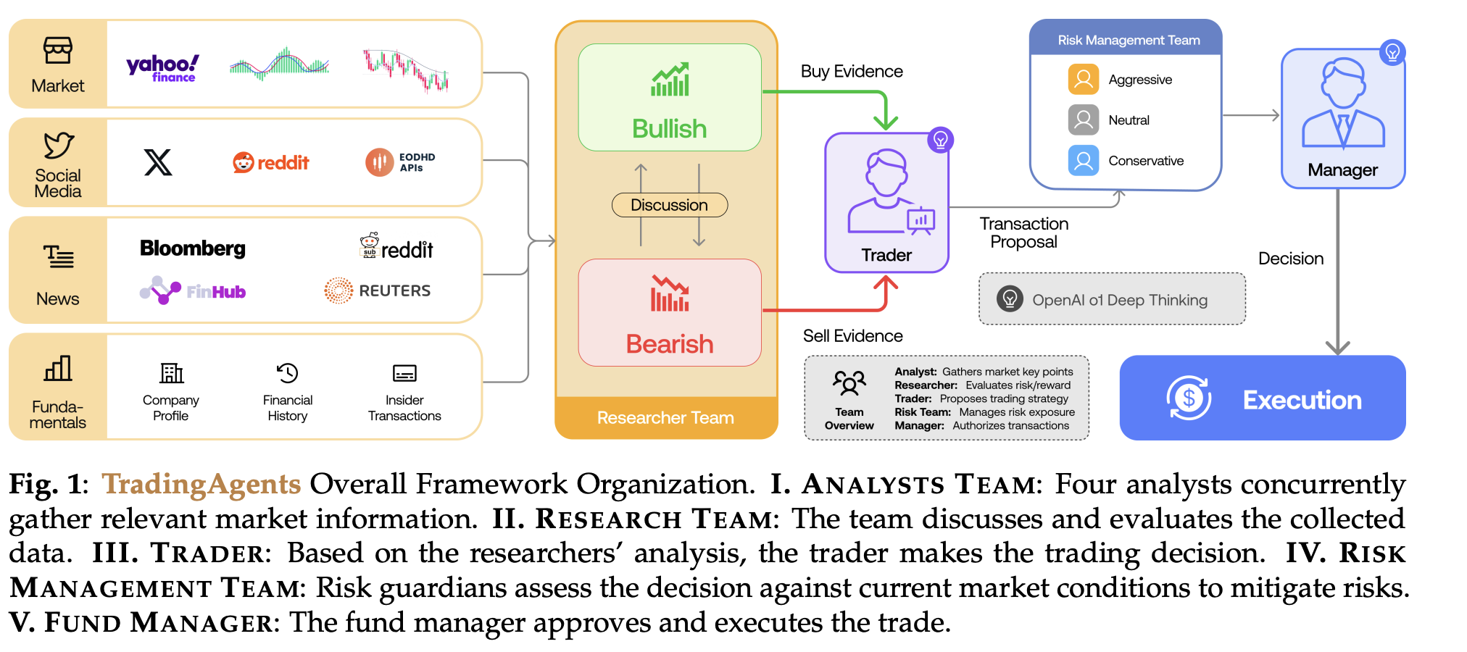
The primary contribution of the paper lies in its novel multi-agent design. Instead of relying on a single model, it decomposes the trading task into multiple specialized components, each of which is easier to interpret and analyze. Multi-agents work the same as the whole investment team. The inclusion of an explicit debate mechanism between bullish and bearish agents is particularly interesting, as it attempts to mimic real-world investment discussions and improve decision quality through structured reasoning.
However, reproducing the results of the paper presents several challenges. First, the computational cost is significant. Each prediction involves approximately 11 LLM calls and more than twenty tool or data retrieval calls, making the system both slow and expensive to run. Our first test running process takes three hours to finish running on two companies trading on a month. To address this, we replaced the original model gpt-4o-mini and o4-mini with Gemini 2.5 Flash Lite, which provides faster responses at a lower cost. In addition, we shorten the period from three months to one month. Second, some of the data sources used in the original implementation, such as insider trading information and Reddit subtopics, are stored locally and are not fully accessible. As a result, we cannot perfectly replicate the original data pipeline. Instead, we substitute social media data with a Kaggle dataset and use the GDELT Project as our primary news source. While this introduces differences in the inputs, we follow the same principle as the authors – report our results faithfully based on our experimental setup.
We evaluate the performance of the TradingAgents framework on AMZN over January 2024 and compare it with several baseline strategies, including Buy-and-Hold and common technical indicators. The full TradingAgents architecture achieves a cumulative return of 4.41% with a Sharpe ratio of 3.90, outperforming the Buy-and-Hold benchmark, which yields a return of 3.51% and a Sharpe ratio of 2.40. This indicates that the proposed framework improves both absolute return and risk-adjusted performance. In comparison with traditional technical strategies, the TradingAgents model demonstrates more consistent performance. While the KDJ + RSI strategy achieves a comparable Sharpe ratio of 3.54, its cumulative return (3.26%) remains lower than that of TradingAgents. Other indicators, such as MACD, exhibit substantially weaker performance, with both lower returns and Sharpe ratios. From a risk perspective, the TradingAgents framework maintains a maximum drawdown of −3.57%, which is slightly lower than the Buy-and-Hold strategy (−3.76%), suggesting modest improvement in downside risk control. The equity curve further shows that the TradingAgents strategy exhibits smoother growth with reduced volatility compared to baseline methods.
Our replication results are similar to the original results, where TradingAgents outperform other baseline models. While rule-based baselines demonstrated superior performance in controlling risk, as reflected by their maximum drawdown scores, they fell short in capturing high return.
To better understand the contribution of each component in the architecture, we design two extension variants. In the first variant, we remove the research debate layer, allowing the analysts to send their reports directly to a research manager before passing them to the trader and risk management modules. In the second variant, we remove the risk management layer entirely, allowing trading decisions to be executed without any explicit risk control. These modifications allow us to isolate the impact of the debate mechanism and the risk layer on overall performance.
The results reveal several important insights. The full architecture achieves a return of 4.41 percent with a Sharpe ratio of 3.90, outperforming a buy-and-hold baseline, which yields a return of 3.51 percent and a Sharpe ratio of 2.40. This confirms that the multi-agent framework adds value compared to a passive strategy. However, when the research debate layer is removed, performance improves significantly to a return of 6.31 percent and a Sharpe ratio of 5.73, making it the best-performing configuration. This suggests that the debate process, while conceptually appealing, may introduce noise or unnecessary complexity in its current form. In contrast, removing the risk management layer leads to a sharp deterioration in performance, with a negative return of 1.33 percent and a Sharpe ratio of negative 0.77. This highlights the critical role of risk control in stabilizing returns and preventing large losses.
These findings suggest a trade-off within the system. The risk management layer is essential for ensuring robustness and protecting against downside risk, while the research debate layer may not yet be effectively contributing to decision quality. One possible explanation is that the debate mechanism is limited to a single round of interaction. Compared to a zero-debate setting, a single round may not be sufficient to refine or aggregate information meaningfully. It is plausible that multiple rounds of structured debate could improve performance by allowing agents to iteratively update and reconcile their views.
In addition, the evaluation is conducted over a relatively short time horizon of one month, which may introduce noise and limit the generalizability of the results. Short-term market fluctuations could disproportionately influence performance, making it difficult to fully assess the contribution of the debate mechanism. On the other hand, the risk layer functions as a constraint-based mechanism, which directly improves the stability of the portfolio.
In conclusion, the TradingAgents framework demonstrates the potential of multi-agent LLM systems in financial applications, particularly in terms of modularity and interpretability. However, our reproduction study indicates that not all components contribute equally to performance. While risk management proves to be indispensable, the debate mechanism does not consistently enhance performance under the current configuration. These findings indicate that increasing architectural complexity does not necessarily translate into better outcomes. Instead, a more streamlined design that combines effective signal generation with robust risk control may achieve superior performance.

